

Proiectarea cu microprocesoare

Documentatie Proiect

Mini sistem de irigare plante

Strugar Madalina – Alexandra

Grupa 30233

2023 – 2024

Descriere:

Am realizat un mini sistem de irigare pentru plante. Acesta verifica constant umiditatea solului, iar cand acesta necesita apa, suntem avertizati print-un semnal luminos si avem posibilitatea de a uda planta in mod automat prin simpla apasare a unui buton.

Componente:

* Placa Arduino Uno
* Breadboard
* Pompa de apa 3-6 V
* Buton
* Led
* 2 * Baterie 1.5 V
* Rezistente
* Fire
* Releu
* Senzor umiditate sol

Schema componentelor:

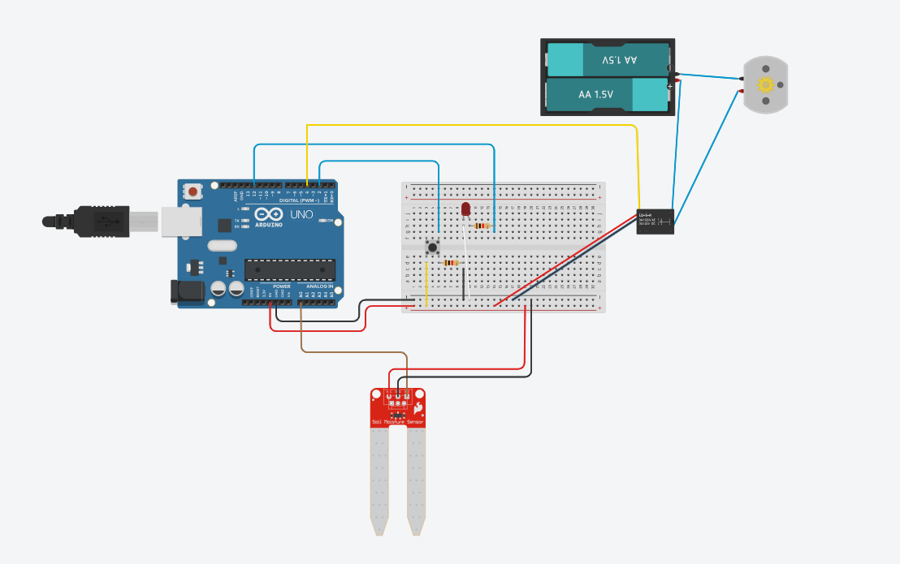

Program:

In partea de setup am ales pinii de input si output pentru fiecare componenta.

In partea de loop, se citesc valorile de la senzorul de umiditate a solului, iar in functie de acesta cunoastem starea plantei(daca are destula apa sau are nevoie de apa etc.). Cand aceasta are nevoie de apa, se va aprinde un led, iar atunci posibilitatea de a uda planta daca apasam butonul, deoarece vom porni pompa care va furniza apa solului.

Cod:

const int moisturePin = A0;

const int ledPin = 12;

const int pumpPin = 4;

const int buttonPin = 2;

const int dry_threshold = 750;

const int humid_threshold = 500;

const int sensorMin = 0;

const int sensorMax = 1023;

const int percentMin = 0;

const int percentMax = 100;

int moistureValue;

int buttonState = 0;

int ledState = 0;

int pumpState = 0;

int percentValue=0;;

void setup() {

  // put your setup code here, to run once:

  pinMode(moisturePin, INPUT);

  pinMode(ledPin, OUTPUT);

  pinMode(pumpPin, OUTPUT);

  pinMode(buttonPin, INPUT);

  digitalWrite(ledPin, LOW);

  digitalWrite(pumpPin, HIGH);

  Serial.begin(9600);

}

void loop() {

  // put your main code here, to run repeatedly:

  moistureValue = analogRead(moisturePin);

  buttonState = digitalRead(buttonPin);

  ledState = digitalRead(ledPin);

  percentValue = (100 - map(moistureValue, sensorMin, sensorMax, percentMin, percentMax));

  if(moistureValue >= 1000) {

     Serial.println("Sensor is not in the soil or it is disconnected! : ");

     Serial.print("Moisture level:");

     Serial.print(percentValue);

     Serial.println("%");

     digitalWrite(pumpPin, HIGH);

     digitalWrite(ledPin,LOW);

  }

  if(moistureValue < 1000 && moistureValue >= dry_threshold) {

     Serial.println("Your plant needs water! :( : ");

     Serial.print("Moisture level:");

     Serial.print(percentValue);

     Serial.println("%");

     digitalWrite(ledPin,HIGH);

     if (buttonState == HIGH) {

        digitalWrite(pumpPin, LOW);

        delay(5000);

        digitalWrite(pumpPin, HIGH);

        digitalWrite(ledPin,LOW);

    } else {

        digitalWrite(pumpPin, HIGH);

    }

  }

  if(moistureValue < dry_threshold && moistureValue >= humid_threshold) {

    Serial.println("Your plant has enough water :D : ");

    Serial.print("Moisture level:");

    Serial.print(percentValue);

    Serial.println("%");

    digitalWrite(pumpPin, HIGH);

    digitalWrite(ledPin,LOW);

  }

  if(moistureValue < humid_threshold) {

    Serial.println("Sensor in water or your plant has too much water! : ");

    Serial.print("Moisture level:");

    Serial.print(percentValue);

    Serial.println("%");

    digitalWrite(pumpPin, HIGH);

    digitalWrite(ledPin,LOW);

  }

  Serial.println("---------------------------------------------------------------------------------------");

  delay(3000);

}

